Overnight 5th Grade Camp 2024
Sunset Elementary PTA

Camp Warm Beach @ Stanwood WA
Friday, April 26th (after school) - Sunday, April 28th, 2024 (2:30pm)
Camp Tuition $275.00 (reduced price from flyer)

Dear 5th Grade Parents,

We anticipate a super fun camp this year! Kids will get to experience unique outdoor camp activities (weather permitting) such as a climbing tower, archery, campfire, dance party and more. This weekend camp (2 overnights) will also give your 5th Grader a chance to demonstrate their independence and maturity as they socialize with their classmates. Your student’s safety and security will be the upmost priority, so please take the time to fill out the enclosed forms. Complete and thorough forms will go a long way to ensure a positive experience for all the kids. In order for us to make final reservations for accommodations and buses, we kindly ask that you complete and return the registration forms on or before the deadline (March 1st, 2024). We cannot guarantee a spot if the registration packet is submitted after the deadline. In mid-April, all registered campers will receive a detailed schedule and itinerary, along with a camp packing list.

Participation and attendance at the overnight 5th Grade Camp is completely OPTIONAL

DEADLINE FOR CAMP REGISTRATION: FRIDAY MARCH 1st, 2024

******************************** Registration Checklist *************************************
Camp Registration Forms (page 2)
Student Health Form (page 3-4)
Student Behavior Contract – requires your child’s signature (page 5)
Tuition Payment Form – attach check or indicate online payment (page 6)
Camp Warm Beach General Activity Waiver (page 7)
Chaperone Interest Form (page 8)
***************************************************************************************************

Please return all completed forms and payment in the envelope provided by Friday March 1st, 2024.
Each 5th Grade Teacher will have a box in the classroom to collect completed camp registration packets. You may keep this cover page for your records.
For more information, please visit the Sunset PTA website or email us at sunsetsockeyecamp@gmail.com with any questions.
An electronic copy of the registration packet and detailed FAQ are also available on the PTA website:
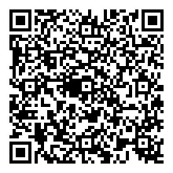

Sunset Elementary Overnight 5th Grade Camp 2024

CAMP/ACTIVITIES TRIP – PARENT/GUARDIAN PERMISSION FORM

ASSUMPTION OF RISK/PERMISSION TO PARTCIPATE
As a parent or guardian of a student requesting to voluntarily participate in a Camp, I hereby acknowledge that I have read, understood, and agreed to the following:
I hereby give permission for
Male
Female
________________________________________ ______/______/______
PLEASE PRINT (Student’s Full Name) (Student’s Date of Birth)
who attends 5th Grade ___________________________ class at Sunset Elementary to take a trip to
(Student’s Teacher)
Camp Warm Beach in Stanwood, Washington by coach (private) bus on April 26h – April 28th, 2024. Estimated time of departure is April 26th at 4:30PM PST and estimated time of return is April 28th 2:30PM PST and participate in the camp activities (except water, please see separate form on page 3).
Parent/Guardian Name:
_____________________________________________________________________________________________
Address:
____________________________________________________________________________________________
Phone #:  ____________________________________________ | Email:  ____________________________________________
Emergency Contact: ____________________________________________ | Phone #:  ____________________________________________
Student’s Physician:  ____________________________________________ | Phone #:  ____________________________________________
Please read the following waivers and acknowledge your agreement with initials in the space provided:
Initial here
_______ I acknowledge that this overnight camp and related activities entail known and unanticipated risks which could result in exposure to COVID19, physical or emotional injury, paralysis, or death, as well as damage to property, or to third parties. I understand that such risks simply cannot be eliminated without jeopardizing the essential qualities of camp and its related activities. I agree to hold and save harmless the Sunset Elementary PTA, its Board and Members, and assignees for any claims, suits, or damages (including but not limited to defense and indemnification) which might result from my student participating in the above-described event/activity.
_______ I, intending to be legally bound, do hereby for myself and heirs, executors, administrators, and assigns, forever waive, release, and discharge all right, claims, and actions for damages that I may have, or that may hereafter accrue to me against the Sunset Elementary PTA, including all unit, council, and district organizations and all of their officers, directors, members, and volunteers.
Initial here
Initial here
_______ I authorize qualified emergency medical professionals to examine and in the event of injury or serious illness, administer emergency care to the above-named student. I understand every effort will be made to contact me to explain the nature of the problem prior to any involved treatment. In the event it becomes necessary for the volunteer staff-in-charge to obtain emergency care for my student, neither s/he nor the Sunset Elementary PTA assumes financial liability for expenses incurred because of the accident, injury, illness and/or unforeseen circumstances.
I understand that I am responsible for any costs associated with an accident or injury. My child has medical/accident insurance: Yes No

Name of Insurance: _________________________ Policy #: ____________________ Group #: ________________
Being fully informed as to these risks, I hereby consent to my student participating in this Camp and Camp activities.
Parent/Guardian Signature:  ___________________________________________________________ |  | Date:  ____________________________

Sunset Elementary Overnight 5th Grade Camp 2024

CONFIDENTIAL HEALTH FORM
To provide a safe & healthy environment for your child, this information with be accessible to Sunset Elementary PTA Camp counselors, chaperones, and health care professionals. A healthcare professional may also follow up with you if additional details are needed.
Male
Female
Student Name _____________________________________________ Birthdate_____/______/______

Parent/Guardian ___________________________________________ Phone # _________________

HEALTH INFORMATION
No Yes _____________________
Does your child have any restrictions on physical activity?
*Camp Warm Beach can only offer a vegetarian option at mealtime.
No Yes _____________________
Does your child have any dietary* restrictions?
List any allergies your child has (food, medication, bee sting, hay fever, hives, etc.). Be specific on the signs & symptoms of your child’s allergic reaction.

__________________________________________________________________________________________
List any chronic disease your child has (diabetes, seizures, rheumatic fever, asthma, etc.)

__________________________________________________________________________________________
No Yes (if yes, provide details below)
Will you be sending medication for your child to camp?

My child will require assistance with his/her medications during Camp.

Medication should only be given IF symptoms occur

Name of Medication:  ____________________________________________ | Reason for taking it:  ____________________________________________
Medical instructions:
____________________________________________________________________________________________
Student’s Physician:  ____________________________________________ | Phone #:  ____________________________________________
I request and authorize the identified Health Care Professional at Camp Warm Beach to administer the identified medication to the above student in accordance with the Health Provider’s prescribed instructions, not to exceed the camp duration of April 26th – April 28th, 2024. I give my permission for exchange of information between the Sunset Elementary PTA 5th Grade Camp chaperone/volunteers and the Licensed Health Care Provider, and the Camp Warm Beach staff. I understand that the medication is to be furnished by me in the original container. For self-administration of inhaler or epi-pen, I authorize my child to carry and self-administer medication as specified. I shall hold harmless and indemnify the Sunset Elementary PTA officers, employees, agents, and 5th Grade Camp chaperone/volunteers against all claims, judgements or liabilities arising out of the self-administration of medication as described.
Parent/Guardian Signature:  ______________________________________________ | Date:  _____________________________________________
CONFIDENTIAL HEALTH FORM (cont’d)
SOCIAL / EMOTIONAL / BEHAVIOR INFORMATION

Student Name: ___________________________________

Camp may be the first time your child spends the night away from you so please share any information that may help counselors make camp a positive experience. Please check any applicable concerns – this information will be kept strictly confidential.

Sleepwalking Bedwetting Nightmares

Please note any Social / Emotional / Behavior Concerns (such as anxiety, ADHD, sensory sensitivities, etc.):

__________________________________________________________________________________________

__________________________________________________________________________________________

__________________________________________________________________________________________

I do hereby authorize that all the above information is correct and that my child is fully able to participate in all Sunset Elementary 5th Grade Camp 2024 at Camp Warm Beach activities. I agree to notify Sunset Elementary PTA of any changes in my child’s physical or mental health between the date of registration and the start of the camp as well as during camp.
Parent/Guardian Signature:  ______________________________________________________________ |  | Date:  _____________________________

Sunset Elementary Overnight 5th Grade Camp 2024

STUDENT BEHAVIOR CONTRACT

Student behavior contract

aPRIL 26TH – APRIL 28TH, 2024
I ____________________________, understand the Sockeye Way that applies at school also applies at Camp Warm
(Student’s Full Name) PLEASE PRINT
Beach:

Be Respectful
Be Responsible
Be Safe
Be Caring

In addition to following school rules, I agree to follow the camp rules listed below:
- Always stay with your group and adult chaperone.
- Practice cleanliness in all areas of the camp
- Be friendly and courteous to all campers and staff.
- Follow the schedule and be on time to activities and meals.
- Use appropriate table manners at all meals.
- Follow safety rules and be a good sport at all times.
- Help protect the environment.
- Stay away from the cabin unless you are with your cabin group and adult chaperone.

I understand that I am responsible for my behavior at all times. If I do not follow the rules at camp, my parents may be called to come and pick me up Camp Warm Beach in Stanwood, Washington.

Student Signature:  ____________________________________________________________ | Date:  ____________________________
Media Release: I hereby grant the SUNSET ELEMENTARY PTA on behalf of my child, the right and permission to photograph and/or record my child in connection with SUNSET ELEMENTARY PTA’s 5th GRADE CAMP at CAMP WARM BEACH. Camp photos will be used to produce a Yearbook Addendum for attending 5th Graders. I waive any right to inspect or approve the use of the photograph and/or recording and acknowledge and agree that the rights granted by this release are without compensation of any kind.

Parent/Guardian Signature:  ____________________________________________________________ | Date:  ____________________________
CAMP PREFERENCES

Camp Crewneck Sweater Size: Youth Medium Youth Large Adult Small Adult Medium
Adult Large

Camp Mates: List up to 2 student campers your child would like to be grouped with. We’ll do our best to match preferences but cannot guarantee any specific groupings.

________________________________________________________________________________________

Sunset Elementary Overnight 5th Grade Camp 2024

TUITION PAYMENT FORM

Camp Tuition for 2024

$275.00

Student Name: __________________________________________
Camp Tuition covers:
- Roundtrip transportation by school bus from Sunset Elementary to Camp Warm Beach.
- 2-night lodging in Mini-Lodges or Mountain Cabins with shared bathrooms
- Use of group meeting spaces
- 6 Meals at Camp and daily snacks and refreshments
- Activity fee for climbing tower, archery tag, etc.
- Camp Crewneck Sweater
- Health care staff

Payment Options

Personal check made payable to “Sunset Elementary PTA”. Please note your student’s name on the check.

[Staple check here]

Online via Credit Card or PayPal (You will need to create a Sunset PTA login. You do not need to be a PTA member).
Scan the QR code

Financial Aid Request. Please complete the following if your student will need financial assistance for the camp tuition.
Student Name | Parent Name
Parent Signature | Date

Refund Policy:
There will be no refunds after March 1st, 2024 (registration deadline), but we will do our best to provide partial refund if you have to cancel for personal/health reasons.

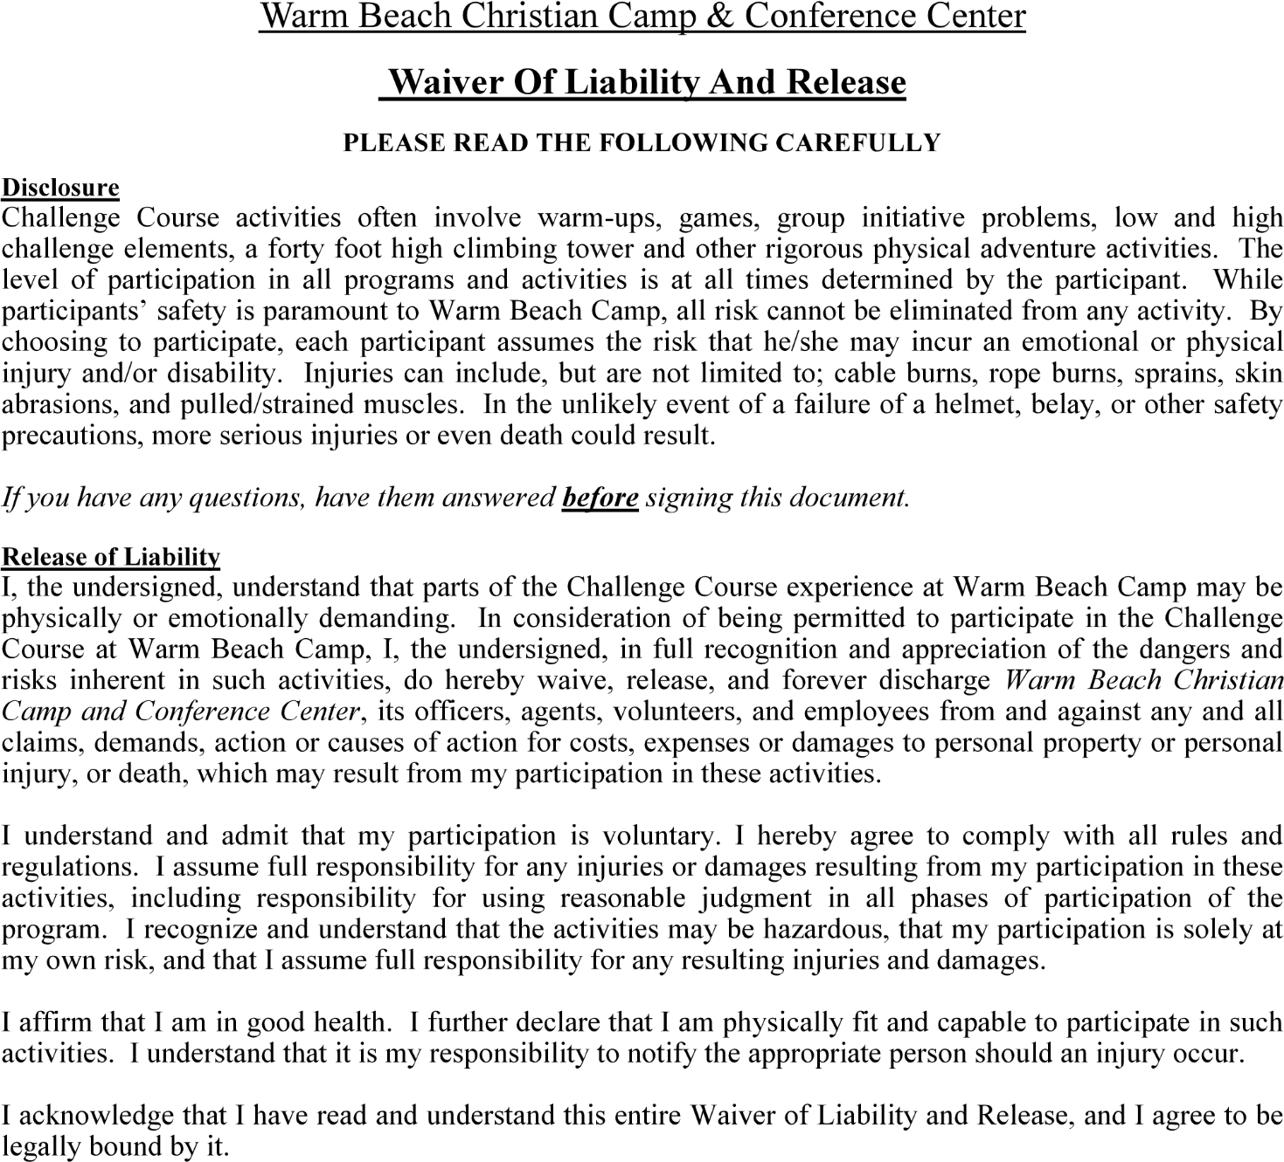

Sunset Elementary Overnight 5th Grade Camp 2024

CHAPERONE INTEREST FORM
This year we need the leadership and support of parents to make Camp a great experience for our 5th Graders.
We are targeting 1 chaperone for every 4-5 kids, so we truly appreciate you making time.

Please check one:

I am INTERESTED in being a chaperone. [see requirements and provide info below]

I NEED to chaperone my child due to his/her medical/social/physical needs.
[add any details here]

_____________________________________________________________________

I am NOT interested being a chaperone. [skip the rest of this form]

CHAPERONE REQUIREMENTS

Mandatory Chaperone Meeting – Date TBD
Camp @ Camp Warm Beach - Friday April 26th 3:45pm - Sunday April 28th 2:30pm

- You will need to be validated through the Issaquah School District volunteer program (https://issaquahvolunteers.myschooldata.net/).
- You will need to pay the per attendee camp fee $275.00 in addition to your child’s camp fee.
- You will be available for the mandatory chaperone meeting and the entire duration of Camp as indicated above.
- You may be asked to drive separately to Camp Warm Beach if space is limited on the student bus.
- You may or may not be assigned to your child’s group or activity times, unless required by my child’s medical/social/physical needs.
- You will be asked to stay in the mini lodge or mountain cabin with another Chaperone and 10 kids for supervision at night – a chaperone is required to be with the kids at night.
- You will need to follow all camp rules and regulations. Help fellow campers (adults and kids) to ensure the safety and security of all.

We will contact selected chaperones in the mid-March 2024 timeframe. At that time, if selected, you will be provided with camp registration forms and waivers to complete for yourself.

Your Name:

_________________________________________________________________________________________
Phone #:  ____________________________________________ | Email:  __________________________________________
Student’s Name:
____________________________________________

